CURRICULUM & ASSESSMENT POLICY

Approved by: | Jenna Constable/Claire Horsfield | Date: 27.06.26
Next review due by: | July 2027
Governors Ratified: | 07/07/2026

Contents

1. INTRODUCTION 3
2. SCOPE 3
3. RESPONSABILITIES AND ACCOUNTABILITIES 4
4. LEGISLATION AND GUIDANCE 5
5. CURRICULUM INTENT 5
6. CURRICULUM PRINCIPLES 6
7. CURRICULUM DESIGN: SPIRAL MODEL 6
8. WHOLE SCHOOL SPIRAL CURRICULUM THEMES 7
9. BECKLANDS AND MILLBROOK STRANDS (SEMH EMBEDDED) 7
10. IMPLEMENTATION 8
11. TEACHING APPROACHES 12
12. TRANSITION AND PROGRESSION 13
13. PHSE AND RSE 14
14. BRITISH VALUES 14
15. ENRICHMENT 15
16. ALTERNATIVE PROVISION 15
17. CAREERS AND PREPARING FOR ADULTHOOD 15
18. POST 16 CURRICULUM 19
19. IMPACT / ASSESSMENT 20
20. DUAL SITES / BLENDED CURRICULUM 22

INTRODUCTION

  - Our Vision: “Believe Inspire Succeed” is underpinned by our mission which is “In the pursuit of excellence, we nurture the potential of every child, regardless of their unique needs. Our core values are centred around Inclusivity, Respect, and High expectations”

  - This policy sets our how we deliver and assess our students not only inline with the statutory guidance but also the vision, mission and values of the school whilst upholding and promoting British Values.

  - We are an independent specialist SEMH school. The school delivers a single, cohesive curriculum across both the main Becklands site and its satellite provision, Millbrook Horizons.

  - The curriculum is available across both sites, ensuring consistency, continuity and breadth of learning for all pupils, regardless of their learning location. Core and foundation subjects are delivered in line with the Becklands curriculum model at both Becklands and Millbrook Horizons, maintaining a shared intent, implementation and approach.

  - Millbrook Horizons enhances this offer by providing additional specialist vocational and practical learning opportunities, including equine studies, horticulture, design technology, animal management and outdoor pursuits. These opportunities complement and extend the core curriculum, supporting engagement, career pathways, independence and preparation for adulthood.

  - Pupils’ timetables may include learning across both sites, with provision carefully matched to their individual needs, interests and aspirations.

  - Alternative Provision is not a core feature of the school’s model. Where it is used, it is carefully planned, time-limited and forms part of a personalised programme, most typically at Key Stage 4 and Post-16. Any external placements are rigorously monitored, in line with Keeping Children Safe in Education, to ensure safeguarding, quality of education and alignment with EHCP outcomes and Preparation for Adulthood goals.

SCOPE

2.1 This policy applies to all students, employees, workers, casual staff, agency staff, contractors, volunteers, Governors, visitors, interns, consultants and other third parties.
2.2 The policy also applies to both sites for the school, The Becklands and Millbrook Horizons.

RESPONSIBILITIES AND ACCOUNTABILITIES

3.1 Proprietor – is responsible for ensuring this policy is implemented fairly and consistently and in a non-discriminatory manner and in adherence to the Independent Schools Standards and any other regulatory body standards where applicable.
3.2 Governing Body – ensure school leadership adheres to this policy, and ensure that the this policy is implemented fairly and consistently and in a non-discriminatory manner and in line with the Independent School Standards any other regulatory body standards where applicable. They will actively partake in decision making about the breadth and balance of the curriculum.
3.2 Executive Board – the Director, or Board of Directors have overall responsibility for ensuring that this policy is applied fairly, consistently and in a non-discriminatory manner. They will apply this policy fairly and consistently in line and act in accordance with the requirements of this policy ensuring that at all times the Policy follows the Independent School Standards and any other regulatory body standards where applicable. They will ensure that a robust framework is in place for setting curriculum priorities and aspirational targets. Ensure that proper provision is made for pupils with different abilities and needs, in particular SEN/SEMH needs as a specialist independent school. Oversee and monitor requests to withdraw children from curriculum subjects where appropriate.
3.2 Head of School or Head of Site/SLT – are responsible for familiarising themselves with this policy and ensuring that all employees are aware of and comply with this policy and any associated procedures. They have a duty to apply this policy fairly and consistently and to act in accordance with the requirements of this policy any other regulatory body standards where applicable. They will ensure that enough teaching time is provided for pupils to ensure they cover the required curriculum under the Independent School Standards. All courses that the school provides for pupils that are accredited are delivered in accordance with the requirements of the awarding body. They will ensure that all the required elements of the curriculum, and those subjects which the school chooses to offer, have aims and objective which reflect the aims of the school and indicate how the needs of individual pupils will be met. They manage requests to withdraw children from curriculum subjects where appropriate and inform the Executive Board of such requests. Ensure the governing body and Executive Board is fully involved in decision making processes that relate to the breadth and balance of the curriculum and involved on whole school targets, progress data and other relevant information such as SEND provision in order to make informed decisions.
3.3 Employees – are duty bound to familiarise themselves with this policy and ensure that they comply with this policy and any associated procedures. All professionals on both sites have a duty to enable all learners to experience a sense of personal achievement by encouraging them to fulfil their potential in different areas relevant to their abilities, skills and interests.
3.4 Employees should also ensure that the raise with HR as soon as possible any adjustments or support that may need to be made to assist them in engaging with this policy.

LEGISLATION AND GUIDANCE

4.1 This policy has due regard to the following legislation, statutory guidance and non-statutory guidance relevant to independent special schools and provision for pupils with special educational needs and disabilities (SEND), including social, emotional and mental health (SEMH) needs.
4.2 Some of the specific legislation which have been considered when producing this policy are:
4.2.1 Independent School Standards (ISS)
4.2.2 Equality Act (2010)
4.2.3 Children and Families Act (2014)
4.2.4 Keeping Children Safe in Education (version in place at any relevant time)
4.2.5 Working Together to Safeguard Children
4.2.6 SEND Code of Practice
4.2.7 British Values guidance
4.2.8 RSE/Health Education guidance
4.3 Other statutory legislation and guidance has been considered and the above list is not considered exhaustive.

CURRICULUM INTENT

5.1 At The Becklands and Millbrook Horizons, we place Social, Emotional and Mental Health (SEMH) at the heart of everything we do. We believe every learner must feel safe, regulated, understood, and valued before they can engage meaningfully in learning. Our curriculum is grounded in trauma-informed practices and a whole-school SEMH approach, supporting regulation, resilience, self-awareness and positive relationships.
5.2 Our curriculum is a trauma-informed, SEMH-first curriculum that prioritises regulation, relationships and real-life readiness, ensuring every learner develops the knowledge, skills and confidence to succeed in adulthood. Our relational approach with learners is a key strength of the team that work at Becklands and Millbrook Horizons.
  - The curriculum is designed to be fully inclusive, removing barriers to learning and ensuring equality of access for all learners, regardless of need, background or starting point. This is also underpinned by access to dual sites with very different learning environments and ways of engaging with learning.

  - Our curriculum:

    - Is fun, engaging and exploratory, designed to promote curiosity and joy.
    - Ensures all pupils develop functional literacy and numeracy skills that enable independence in real-life contexts (e.g., communication, budgeting, accessing services).
    - Is individualised and learner-led, tailored to EHCP outcomes and pupil voice.
    - Prioritises emotional literacy, communication, and self-advocacy.
    - Scaffolds learning to ensure progress, retention, and long-term mastery.
    - Promotes mental wellbeing, self-regulation, identity and self-expression.
    - Emphasises positive relationships, social interaction and community belonging.
    - Provides life skills, qualifications and employment pathways for meaningful futures.
    - Is delivered in an exciting and stimulating learning environment in which learners feel valued, safe and able to learn.

CURRICULUM PRINCIPLES

6.1 Our curriculum principles are:
6.1.1 Regulation before cognition
6.1.2 Functional independence over abstract knowledge
6.1.3 Repetition and overlearning
6.1.4 Personalisation with ambition

CURRICULUM DESIGN: SPIRAL MODEL

7.1 Our curriculum is structured using Jerome Bruner’s Spiral Curriculum Model, allowing learners to revisit key themes and concepts at increasing levels of complexity. This promotes deeper understanding, knowledge retention, and emotional engagement with learning over time. Our learners contribute to curriculum development through pupil voice, EHCP reviews, and personalised learning planning.
7.2 Knowledge Progression
- Core knowledge is mapped across all subjects and revisited through spiral themes
- Vocabulary progression is explicitly planned
- Skills move from supported → scaffolded → independent application

WHOLE SCHOOL SPIRAL CURRICULUM THEMES

8.1 Building on the spiral curriculum model we apply this in a cross-curriculum manner to allow for students to revisit learning and build on core areas. Full details of the topics are found in Long Term Plan 2025-2026.docx. Examples of the cross curricula / spiral approach can be demonstrated in some of our whole school spiral curriculum themes which include:
8.1.1 Our World and Beyond - Revisiting geography, science and literature through ecosystems, space and environmental issues. SEMH links: Awe and wonder, connectedness to nature, global citizenship, future thinking. Curriculum map Our World and Beyond.docx
8.1.2 Heroes and Role Models - Studying historical figures, sports personalities, and fictional heroes. SEMH links: Aspiration, identity, values, positive role modelling, resilience. Curriculum map Heroes and role models.docx
8.1.3 Cultural Celebrations - Exploring festivals, traditions, and global cultures. SEMH links: Belonging, empathy, community, respect for diversity. Curriculum map Culture Celebrations .docx
8.1.4 Health and Wellbeing - Looking at mental health, nutrition and physical activity. SEMH links: Emotional regulation, coping strategies, self-care. Curriculum map Health & Wellbeing .docx
8.1.5 Creativity and Imagination - Focusing on storytelling, artistic expression and music composition. SEMH links: Emotional expression, self-esteem, catharsis. Curriculum map Creativity & Imagination .docx
8.1.6 Problem Solving and Enterprise - Encouraging critical thinking, financial literacy and teamwork. SEMH links: Independence, future planning, collaboration, perseverance. Curriculum map Real-World Problem Solving & Smart Living.docx

BECKLANDS AND MILLBROOK STRANDS (SEMH EMBEDDED)

9.1 In order to ensure that our SEMH curriculum is embedded within all we do, we use our “5 strands” model which is:
- Helping Others – community engagement, empathy, volunteering
- Exploring the Environment – outdoor learning, sustainability, exploration
- Skills for Life – independence, communication, daily living skills
- Healthy Living – physical and mental wellbeing, self-regulation
- Preparation for Adulthood – careers, enterprise, employability, self-advocacy
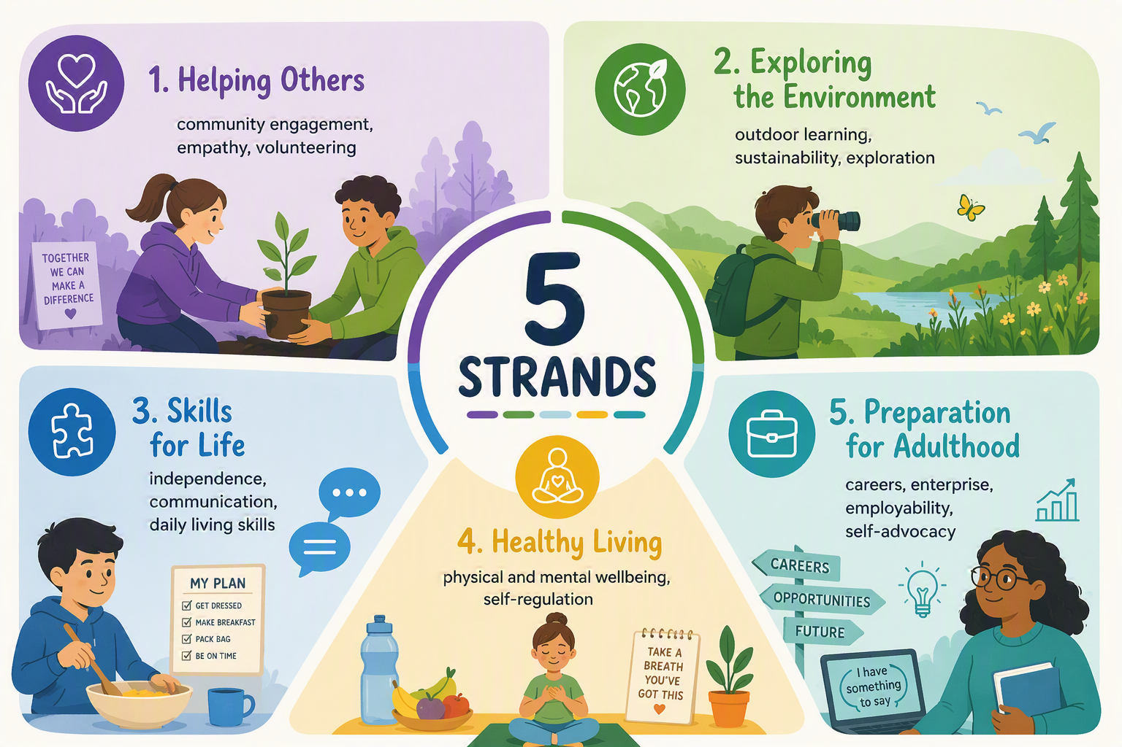

9.2 Our curriculum is a broad and balanced curriculum approach where skills, knowledge and vocabulary are equally valued. The personalised design of our curriculum helps children to acquire the knowledge they need to learn ever more complex skills and then gives them opportunities to practise and apply them over time, in order to master them. This approach to curriculum design means the “5 strands” are integrated into all aspects of the curriculum and frequently work towards EHCP targets in addition to academic outcomes.

IMPLEMENTATION

10.1 Our curriculum is outcome focused, ensuring that all groups of learners, regardless of background, culture or ability have the knowledge, opportunities, skills and accreditation needed for life after their time with us.
10.2 For all our learners regardless of their starting point, we provide a curriculum that promotes the spiritual, moral, social, cultural, mental, cognitive and physical development and prepares learners at the school for the opportunities, responsibilities and experiences of later life.
10.3 We incorporate external accreditations where appropriate, through the use of a wide range of qualifications including Functional Skills, entry level certificates, BTECs, AQA Awards, British Horse Society qualifications, and the Award Scheme Development and Accreditation Network (ASDAN).The curriculum actively promotes safeguarding, British Values, equality, and protected characteristics, ensuring pupils are prepared for life in modern Britain.
10.4 We also provide a wide range of additional opportunities for learning and development for example: DoE, work experience, volunteering, lessons in First Aid, Health and Safety which provide further opportunities to develop personal and employability skills.
10.5 In terms of curriculum content, we deliver a carefully planned and sequenced curriculum that builds coherently throughout a learner’s time at school. Teachers/Instructors follow this curriculum which is set out in the long-term/ medium term plans and intent documents. Teachers/Instructors devise a detailed scheme of work in order to meet the personalised needs and challenge learners to achieve their full potential.
10.6 The content of the curriculum meets Part 1 of the Independent School Standards in all areas in that it covers a wide range of subjects, specifically ensuring that the range of subjects gives pupils experience of:
10.6.1 Linguistic;
10.6.2 Mathematical;
10.6.3 Scientific;
10.6.4 Technological;
10.6.5 Human and Social;
10.6.6 Physical;
10.6.7 Aesthetic / Creative Education; and
10.6.8 Careers guidance (for students within the required age range).
10.7 In addition to the above we offer a wide range of other learning opportunities, many of which have cross curricula links and can utilise learning opportunities within the spiral curriculum model which include:
10.7.1 Equine Studies
10.7.2 Outdoor Pursuits
10.7.3 Design Technology
10.7.4 Horticulture
    - Animal Care
10.7.6 Hair and Beauty
10.7.7 SMSC – as a standalone lesson as well as integrated throughout the curriculum
10.8 The above is further is enhanced with the “5 strands model” as well as well as Self-advocacy, Careers Education, Enterprise, Financial Planning, Physical Development, Understanding the World, Duke of Edinburgh, Personal Development, Employability Development, The Becklands Baccalaureate, Work Experience, Careers Education, Information, Advice and Guidance and Charitable Work
10.8 Curriculum implementation is tailored to each student’s needs – we recognise that many children come to with below age related expectations. This could be due to many reasons such as gaps in their education, difficulties engaging in education as a result of their SEMH / SEN needs. Therefore, we have schemes of work in place across all key stages to ensure the curriculum is accessible and inclusive of all student abilities.
  - For learners in Years 5 and 6, the curriculum is carefully adapted to provide a strong foundation for future learning whilst maintaining the school's SEMH-first approach. Learners access the same ambitious spiral curriculum model as their older peers, enabling them to revisit key knowledge, skills and vocabulary over time so that they learn more, remember more and build secure foundations for future success. Teaching is personalised to reflect individual starting points, EHCP outcomes and identified SEMH needs, with a strong emphasis on emotional regulation, readiness to learn, communication, resilience and positive relationships. Alongside targeted support to develop literacy, numeracy and social skills, pupils access a broad and balanced curriculum including English, mathematics, science, art, design technology, music, history, geography, computing, PSHE, physical education and outdoor learning. Learning is carefully sequenced to develop both subject-specific knowledge and essential life skills, ensuring pupils are well prepared for successful transition into Key Stage 3, later education, employment and independent adulthood.

  - Post 16 education is set out in a separate section below.

  - We offer three different curriculum pathways to our pupils:

  - The pathways are not necessarily sequential, neither are they linked to chronological age. The learner follows the pathway that best meets their developmental needs rather than their age. For example, an 11-year-old pupil could follow the Formal pathway whilst a 15-year-old pupil may follow the Pre-formal pathway.

  - Each curriculum pathway has elements which overlap and are embedded into each other to allow easy transition for pupils who may transition from one to another. This can be in any direction and will entirely be based on their needs.

  - Our curriculum effectively supports a total communication approach which encourages all forms of communication, developing children's language skills and ensuring social, emotional and academic progress simultaneously.

  - This enables learners to study at a level appropriate to their needs and abilities. Learners are never restricted by these pathways and are able to move between the pathways.

  - The school is committed to a multi-disciplinary implementation approach: class teams work closely with a range of professionals, specialist teachers/instructors and support staff to enable the best outcomes for the learners.

  - The Becklands School and Millbrook Horizons are committed to supporting the learner's health and well-being including their social and emotional needs through targeted intervention. The aim is to provide accessible, flexible, confidential, and therapeutic support for vulnerable learners who are experiencing a range of social, emotional, and behavioural difficulties to increase their capacity to learn and engage fully in school life. Support is available throughout the day and is highly personalised to the needs of the learner. It is integrated, not intrusive, proactive, rather than reactive and increasingly owned by the young person. The details of which are set out in our Education Behaviour Support Policy.

  - The whole school timetable and curriculum are reviewed annually to ensure compliance with current legislation and guidance, considering best practice within special needs education. However, we may review the individual timetables of students if this is required during the academic year.

  - The curriculum is underpinned by a clear and coherent planning framework to ensure progression, consistency and personalisation:

    - Long-term plans set out the whole-school spiral curriculum intent, themes and progression across key stages.
    - Medium-term plans sequence learning within each term, ensuring knowledge, skills and vocabulary are revisited and built upon through the spiral curriculum.
    - Schemes of work provide detailed subject-specific planning, including learning objectives, teaching approaches, assessment opportunities and adaptive strategies.
    - Personal Learning Goals (PLGs) and individual SEND provision maps support EHCP outcomes and ensure that learning is highly personalised, with clear targets linked to Preparation for Adulthood.

  - This layered approach ensures that all learners access a broad, balanced and ambitious curriculum while meeting individual needs.

TEACHING APPROACHES

  - Teaching approaches at the Becklands and Millbrook Horizons include:

    - Explicit instruction and modelling
    - Chunked learning and scaffolding
    - Retrieval practice and overlearning
    - Regulation-first strategies before learning
    - Adapted communication (visuals, AAC, total communication)
    - Flexible pacing based on need

  - Literacy, Oracy and Numeracy Across the Curriculum: The development of speaking, listening, literacy and numeracy is a core priority and is explicitly taught, practised and applied across the curriculum.

  - Literacy and Communication (including Oracy):

    - Explicit teaching of reading, writing, vocabulary and comprehension skills
    - Structured opportunities for speaking and listening, including discussion, role play and presentation
    - Total Communication approaches, including AAC, visuals and modelling

  - Numeracy:

    - Direct teaching of functional mathematical skills
    - Application of numeracy in real-life contexts such as budgeting, time and problem solving

  - Across the curriculum:

    - These skills are revisited in all subjects through planned opportunities for application
    - Teachers model and scaffold language and mathematical thinking
    - Retrieval practice and overlearning support long-term retention
This ensures learners develop the skills needed for independence and meaningful participation in society.

TRANSITION AND PROGRESSION

12.1 At The Becklands School, transition is a carefully planned and personalised process that ensures continuity, progression, and success for every learner. On entry, all pupils undertake a comprehensive baseline assessment, drawing on EHCP information, prior attainment, and a range of diagnostic tools to identify academic levels, communication needs, and SEMH readiness. This baseline informs individualised curriculum pathways and ensures that learning begins at an appropriate and aspirational starting point.
12.2 Our satellite site at Millbrook Horizons is frequently used to re-engage learners in education via a non-traditional classroom based environment. Allowing for the development of trusted relationships, routine, structure and learning to occur withing a nurturing and supportive environment.
12.2 Transition between the pre-formal, semi-formal and formal pathways is fluid and responsive, based on ongoing assessment and the evolving needs of the learner rather than age or year group. Regular review points, including pupil progress meetings and EHCP reviews, ensure that any movement between pathways is timely, well-supported and in the best interests of the learner, enabling them to access increasing levels of challenge, independence and accreditation where appropriate.
12.3 Preparation for transition beyond Becklands and Millbrook is embedded throughout the curriculum, with a strong focus on Preparation for Adulthood outcomes. From Key Stage 4 onwards, learners are supported to plan their next steps through high-quality careers education, work experience, and personalised guidance. We work closely with families, external providers and employers to ensure that each learner transitions successfully into further education, employment or training, equipped with the skills, confidence and resilience needed to thrive in adult life.

PHSE AND RSE

13.1 PSHE is central to the school’s curriculum and reflects the school’s ethos of inclusivity, respect and high expectations. It supports learners’ personal development, wellbeing and preparation for life beyond school.
  - The PSHE Jigsaw curriculum:

    - Promotes emotional wellbeing, resilience and self-regulation
    - Develops understanding of relationships, health, safety and life skills
    - Supports pupils to develop confidence, independence and self-advocacy

  - Relationships and Sex Education (RSE) is delivered in an age-appropriate and needs-led way and is adapted to reflect learners’ developmental stages.

  - PSHE and RSE are delivered through structured lessons, assemblies and wider curriculum opportunities, and are reinforced through the school’s relational and therapeutic approach.

BRITISH VALUES

14.1 British Values underpin the ethos and daily practice of the school. These values—democracy, the rule of law, individual liberty, mutual respect and tolerance—are actively promoted through all aspects of school life.
  - Pupils are supported to:

    - Develop respect for themselves and others
    - Understand their rights and responsibilities
    - Engage positively with their community
    - Appreciate diversity and challenge discrimination

  - These values are embedded through the curriculum, PSHE, assemblies, behaviour approaches and pupil voice opportunities and are evidenced in the relevant scheme of works.

ENRICHMENT

15.1 The curriculum is enriched by educational visits, outdoor learning, local community links and opportunities within the timetable to engage with new experiences, for example: participation in art, music and dance festivals.
15.2 We also have frequent events and sessions in school involving the wider community from Charity Coffee Mornings, to art exhibitions to our annual Bright Stars events, students have a wide range of opportunities to engage with the wider school community.

ALTERNATIVE PROVISION

  - All students have access to our satellite site Millbrook Horizons which in addition to the being able to deliver a large range of the core offer, is we deliver specialist subjects such as Equine, Animal Care, Design Technology, Horticulture etc. This gives students opportunities to have practical hands-on learning outside of a traditional classroom environment.

  - Other provisions we may use from time to time include opportunities in areas such as sports, hair and beauty, music production, and motor mechanics. These tend to be accessed more by students who are accessing our Post-16 offer or where they link to specific needs which we are not able to meet from our diverse curriculum.

  - Many of the above APs we may use from time to time link into to our offer but are able to offer the learners specific outcomes or qualifications we may not be able to. For example, music production – students have access to a wide range of creative and aesthetic curriculum which includes music sessions, however, if they wish to obtain a specific qualification in this area we are able to use an AP to support them.

  - By offering diverse pathways, we aim to nurture individual interests and talents, enabling learners to develop practical skills alongside their academic learning. This approach supports personal development, increases motivation, and equips learners with the knowledge, confidence, and employability skills they need to succeed in adulthood and make informed choices about their future.

CAREERS AND PREPARING FOR ADULTHOOD

17.1 Careers are taught through the PSHE Curriculum in Secondary (Key Stage 3) and as part of the bespoke curriculum at Key Stage 4 and Sixth Form. KS4 and Sixth Form have a tailored Careers programme which provides individual and group opportunities for young people to develop their knowledge, skills and understanding. Links with Careers advisors strengthen the advice and guidance offered. Tailored sessions are accessed by individuals and small groups to develop work skills and provide work experience off site.
17.2 Learners follow a pathway tailored to their individual needs and required outcomes. These pathways include a challenging set of objectives to ensure the interests and ambitions of each student are met and fully achievable. Targets are set to build Social, Independence and Employability Skills in line with Preparation for Adulthood outcomes.
17.3 Our dedicated team work alongside each learner to ensure that goals (dreams, hopes, aspirations) are identified, planned and reached. An internal key worker system is used to track and monitor individual goals on a weekly, termly and yearly basis. This allows for each learner and staff member to identify areas that are working well and conversely if any areas need extra support. 1:1 Careers meeting with a dedicated Careers advisor happen across the school.
  - Enterprise is embedded into all subject areas and the key Enterprise principles are revisited throughout the school year. Emphasis is put on how a venture is planned and implemented as well as the product/service outcome, this allows for a broader range of skills to be experienced and gained. Self-reflection and evaluation is a key part of any learning and Enterprise is no exception.

  - The programme begins in Key Stage 2/3 and builds through to Post-16, is aligned with the Gatsby Benchmarks, and is linked directly to EHCP outcomes and Preparation for Adulthood goals.

  - Learners receive:

    - Individual careers guidance interviews
    - Personalised pathways and target setting
    - Work-related learning and experience
    - Employer engagement and vocational opportunities

  - Provision is adapted to ensure accessibility for all learners, including those with SEMH needs, ensuring meaningful and aspirational outcomes.

  - Careers and Work Opportunities on offer include:

    - Travel Training
    - Land based studies (Farm-based)
    - Animal Care
    - Equine
    - Design technology techniques, egg Woodwork
    - Duke of Edinburgh
    - Hair and Beauty
    - Horticulture
    - Links with other FE providers
    - Links with local employers
    - Charity work/ volunteering
    - Dog walking

  - Links with Businesses and Employers: There is a dedicated Careers and a Vocational Learning lead within school. The links with employers and vocational providers has been strengthened through the involvement in network groups and by dedicating time to developing links and relationships with external agencies and employers. The ethos of the school encourages people to look within the community to provide specialist support, knowledge and information to pupils and teachers. Teachers constantly look to the community for ways of enriching learning and making it real for the pupils.

  - Enrichment weeks and whole school topic events = focus on providing an opportunity for pupils to be immersed within different themes and to learn about the world of work, both through educational visits and guest visitors and speakers.

  - We have strong links with large businesses and local businesses for example, at the time of reviewing this policy this includes:

    - Acorns (Charity shop)
    - Medd’s Motors
    - Helping Others Mental Health Charity
    - Echo (hair salon)
    - Starsdale Farm

  - We are continually working within the local community to build these links and opportunities for learners. These employers and sole traders have given valuable work experience, input and advice to our students as well as contributing to practical hands on skill-based activities.

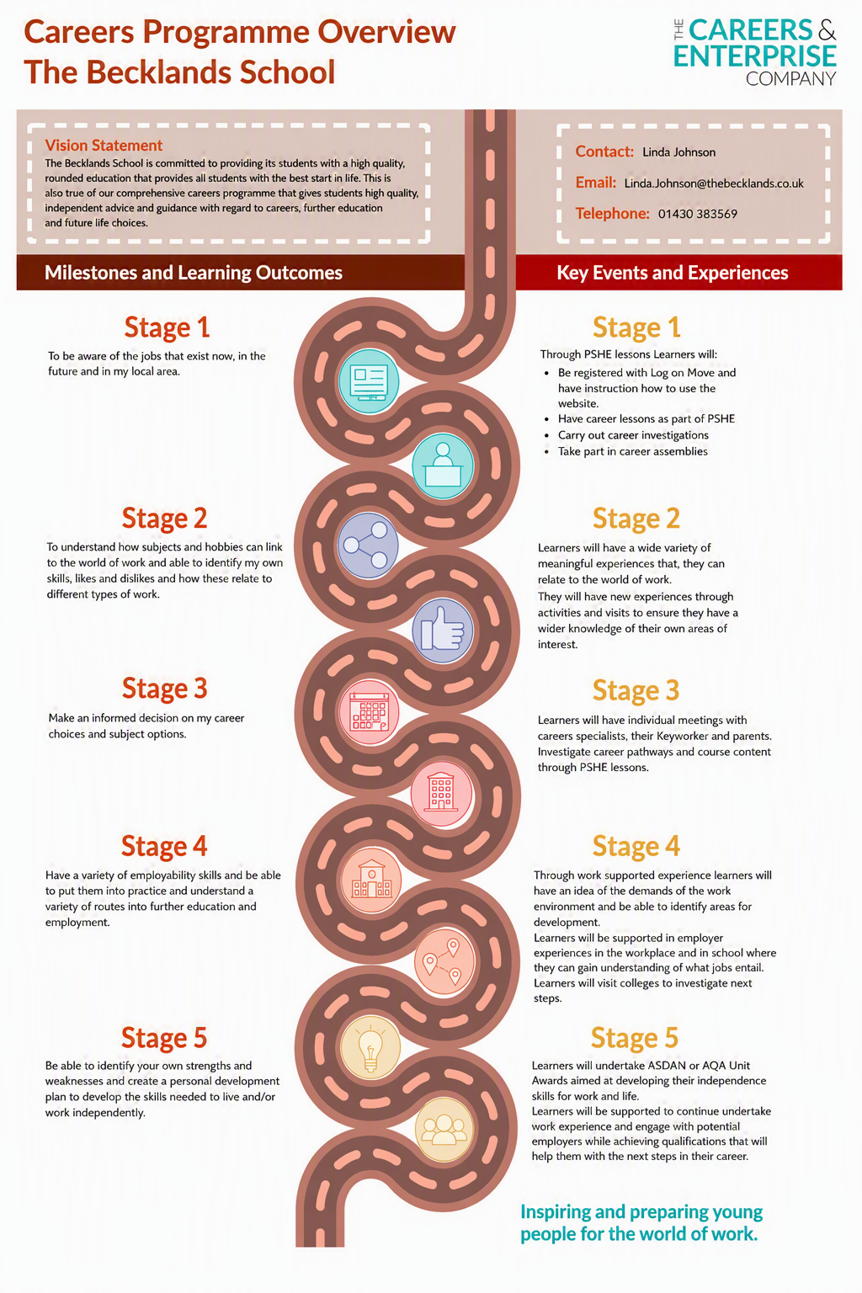

POST 16 CURRICULUM

18.1 The Post-16 curriculum at The Becklands School and Millbrook Horizons is designed to prepare students effectively for adulthood by providing a personalised, aspirational, and outcomes-focused learning experience.
18.2 At this stage, there is a strong emphasis on developing independence, life skills, and readiness for the next stage of education, employment, or training. The Post-16 curriculum focuses on enabling students to make informed choices and decisions about their futures, while building the confidence, resilience, communication skills, and positive attitudes required to succeed as young adults.
18.3 The Post-16 curriculum is delivered primarily across Becklands and Millbrook Horizons, with carefully selected external placements used to enhance vocational and employment pathways where appropriate.
18.4 A key feature of the Post-16 offer is the integration of real-life experiences, including structured work experience opportunities and exposure to a range of workplace environments. These experiences are carefully matched to students’ interests, strengths, and intended career pathways, and are supported by partnerships with alternative provisions and specialist training providers where appropriate. This ensures that students can access bespoke opportunities that reflect their aspirations and support meaningful progression routes.
18.5 The curriculum includes the ASDAN Personal Development Programme, which plays a central role in supporting students to develop essential life skills such as problem-solving, teamwork, communication, and self-management. This is complemented by a holistic approach that prioritises resilience-building and independence, ensuring that learners are equipped to navigate the challenges of adult life.
18.6 All students within the Sixth Form access a broad and balanced curriculum aligned closely with the Preparation for Adulthood agenda. This includes work-related learning, community inclusion, travel training, independence and life skills, as well as opportunities to engage in leisure activities. In addition, Relationship and Sex Education (RSE), Personal, Social, Health and Economic (PSHE) education, sport, and creative and expressive arts form an integral part of the curriculum. These areas are, where appropriate, linked to accreditation routes, ensuring that students’ achievements are formally recognised.
18.7 Students continue to follow their personalised learning goals which are informed by Pupil Progress Meeting (PPM) and aligned with their Education, Health and Care Plan (EHCP) outcomes. These plans maintain a strong focus on Preparation for Adulthood outcomes and are used to guide both curriculum planning and ongoing assessment, ensuring progress is meaningful and measurable.
18.8 We are committed to providing high-quality careers education, information, advice and guidance. This is reflected in consistently strong COMPASS evaluation results, demonstrating our ongoing commitment to meeting all eight Gatsby Benchmarks. Through this robust and well-planned curriculum, we ensure that all Post-16 students are supported to achieve the best possible outcomes and transition successfully into the next stage of their lives.

IMPACT / ASSESSMENT

  - Assessment at The Becklands School and Millbrook Horizons is purposeful, continuous and integral to teaching and learning. It is used to:

    - Identify gaps in knowledge, skills and SEMH readiness
    - Inform responsive teaching and immediate adaptations to meet individual needs
    - Track progress towards EHCP outcomes and Preparation for Adulthood (PA) goals
    - Support timely movement between curriculum pathways where appropriate

  - The impact of the curriculum is evaluated through a robust cycle of assessment, monitoring and review.

  - The Executive Board Members, Heads of School/Site and Senior Leadership Team coordinate a comprehensive quality assurance cycle, working in partnership with staff, parents and external professionals to ensure consistently high standards.

  - All QA is overseen and centralised from both sites by the named Headteacher, Claire Horsfield.

  - Leaders implement a robust cycle of monitoring, evaluation and review to ensure the quality and impact of the curriculum. This includes:

    - Lesson observations, learning walks and teaching reviews
    - Work scrutiny and curriculum deep dives
    - Analysis of pupil progress and assessment data
    - Review of EHCP outcomes and adaptations for pupils with SEND
    - Evaluation of subject knowledge and curriculum delivery
    - Monitoring of resource use and learning environments
    - Pupil voice, parent feedback and staff input

  - Leaders use this information to:
    - Identify strengths and areas for development
    - Inform professional development and training
    - Ensure high-quality teaching and learning
    - Adapt provision to meet the needs of all learners

  - This ensures continuous improvement and high standards across the school.

  - EHCP outcomes form a key component for curriculum planning and assessment. These outcomes directly inform both formative and summative assessment, aligned with the national Engagement Model for learners working below the standard of national curriculum assessments.

  - EHCP targets are closely linked to identified areas of need and Preparation for Adulthood priorities, ensuring that progress is meaningful, personalised and aspirational.

  - Assessment is both formative and summative, providing a holistic picture of each learner:

    - Formative assessment is embedded in daily practice through strategies such as retrieval tasks, fluency activities, knowledge harvests, low-stakes quizzes and ongoing teacher observation.
    - Summative assessment data is collected at least three times per year for learners in the formal and semi-formal pathways.
    - For pre-formal learners, a more holistic and developmental approach is used, including observational assessment recorded through Tapestry alongside structured assessment where appropriate.
    - A range of assessment tools and accreditation pathways are used to evidence progress and achievement:
    - Learners in Key Stage 4 and Post-16 access external accreditation, including NOCN and OCR courses, Entry Level Certificates, BTEC qualifications, Functional Skills, GCSEs, AQA Awards, British Horse Society qualifications, ASDAN.
    - Learners working below Key Stage 1/2 are assessed using Becklands B Scales, which provide a structured progression framework linked to Development Matters and support the setting of appropriately challenging targets.
    - Tapestry is used across the school to capture and evidence practical, experiential and developmental learning.
    - Sonar is used to track and analyse both formative and summative assessment data over time.
    - Standardised and diagnostic assessments, including NOCN diagnostics, IDL, WRAT5 and Boxall Profile, are used to establish baselines, monitor academic progress and assess SEMH development.

  - The impact of the curriculum is also reflected in communication with parents and carers:
    - Progress is shared regularly through half-termly Learner Progress Reports (LPRs), termly Parents’ meetings, Annual Review documentation and end-of-year reports.
    - Parents and carers are encouraged to engage in ongoing dialogue with the school to support their child’s development.

  - Overall, the impact of the Becklands curriculum is demonstrated through:

    - Measurable progress from individual starting points
    - Successful achievement of EHCP outcomes and PFA goals
    - Improved engagement, behaviour and emotional regulation
    - Increased independence, communication and self-advocacy
    - Accreditation outcomes and qualifications achieved
    - Positive transitions into further education, employment or training

DUAL SITES / BLENDED CURRICULUM

20.1 In having dual sites the way in which the curriculum is delivered and the learning environment is fundamentally different. Students may be based between both sites, Becklands and an alternative AP, Becklands and Millbrook or solely at Millbrook. Decisions as to where to timetable students is based on a wide range of factors, for example we take into account their needs, chronological age, as well as their career aspirations.
20.2 In practice, learning at Millbrook Horizons is predominantly experiential, alongside structured delivery of core subjects ensuring adherence to the Independent School Standards and line with the Becklands School approach.
20.3 Learners engage in daily activities that combine practical application with underpinning theoretical knowledge.
20.4 Teaching approaches at Becklands School ad Millbrook Horizons are adaptive, personalised, and highly supportive, ensuring that all learners can access both the vocational and academic curriculum at an appropriate level. Staff use ongoing assessment to identify progress, tailor learning experiences, and celebrate success, with a strong emphasis on small-step achievements. The curriculum also places a significant focus on developing life skills, communication, and employability, ensuring learners are well prepared for adulthood. These are key themes that are seen across both sites.

