The Becklands School Curriculum & Assessment Policy 2025

(Revised with SEMH and Spiral Curriculum Focus)

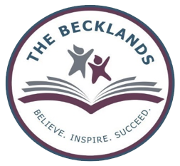

Written by: Jenna Constable
Review date- 02.10.25

Our vision:
“In the pursuit of excellence, ​we nurture the potential of every child, regardless of their unique needs. Our core values are centred around Inclusivity, Respect, and High expectations.

Our curriculum INTENT is to:

At The Becklands School, we place Social, Emotional and Mental Health (SEMH) at the heart of everything we do. We believe every learner must feel safe, regulated, understood, and valued before they can engage meaningfully in learning. Our curriculum is grounded in trauma-informed practices and a whole-school SEMH approach, supporting regulation, resilience, self-awareness and positive relationships.
Our curriculum:
- - Is fun, engaging and exploratory, designed to promote curiosity and joy.
- - Develops core literacy and numeracy, ensuring functional and transferable skills.
- - Is individualised and learner-led, tailored to EHCP outcomes and voice.
- - Prioritises emotional literacy, communication, and self-advocacy.
- - Scaffolds learning to ensure progress, retention, and long-term mastery.
- - Promotes mental wellbeing, self-regulation, identity and self-expression.
- - Emphasises positive relationships, social interaction and community belonging.
- - Provides life skills, qualifications and employment pathways for meaningful futures.

Curriculum Design: The Spiral Model
Our curriculum is structured using Jerome Bruner’s Spiral Curriculum Model, allowing learners to revisit key themes and concepts at increasing levels of complexity. This promotes deeper understanding, knowledge retention, and emotional engagement with learning over time.

Whole School Spiral Curriculum Themes:
See long term plan for more details on each topic. Long Term Plan 2025-2026.docx

Our World and Beyond
Revisiting geography, science and literature through ecosystems, space and environmental issues. SEMH links: Awe and wonder, connectedness to nature, global citizenship, future thinking. Curriculum map Our World and Beyond.docx

Heroes and Role Models
Studying historical figures, sports personalities, and fictional heroes. SEMH links: Aspiration, identity, values, positive role modelling, resilience. Curriculum map Heroes and role models.docx

Cultural Celebrations
Exploring festivals, traditions, and global cultures. SEMH links: Belonging, empathy, community, respect for diversity.

Health and Wellbeing
Looking at mental health, nutrition and physical activity. SEMH links: Emotional regulation, coping strategies, self-care.

Creativity and Imagination
Focusing on storytelling, artistic expression and music composition. SEMH links: Emotional expression, self-esteem, catharsis.

Problem Solving and Enterprise
Encouraging critical thinking, financial literacy and teamwork. SEMH links: Independence, future planning, collaboration, perseverance.

Our Becklands Strands (SEMH Embedded):
- - Healthy Living
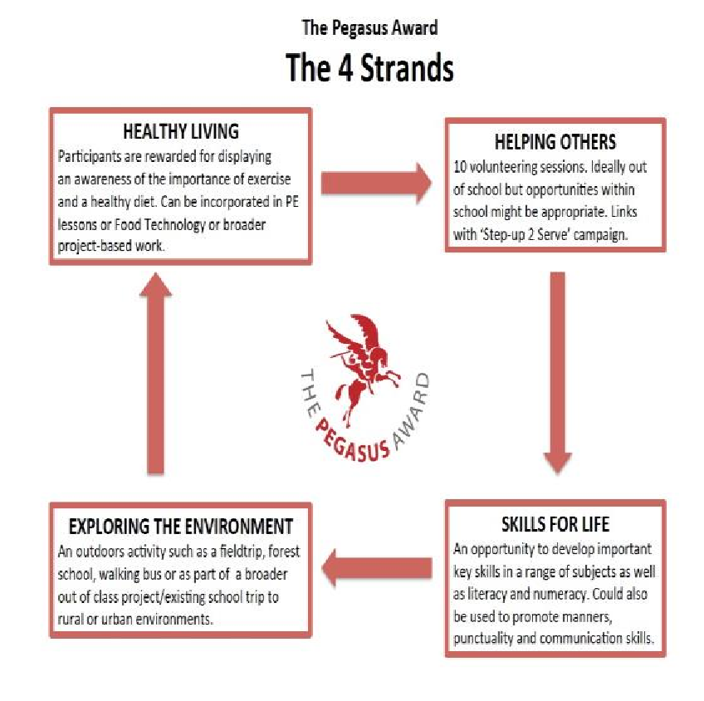

- - Helping Others
5th strand:
Preparation for adult hood
- Careers
- Work Experience
- CEAIG
- Enterprise
- Charitable work
- Citizenship/ character building
- Quality enrichment activities
- Communication and social interaction
- Self-advocacy

- - Exploring the Environment
- - Skills for Life
- - Preparation for Adulthood
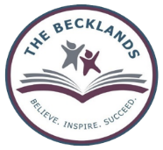

The EHCPs areas of need and Preparation for Adulthood outcomes play a central role in The Becklands School Curriculum, ensuring a bespoke and needs-based approach to supporting learners and learners’ progression of skills through different key stages towards independence and full participation in adulthood.

The Becklands curriculum is a broad and balanced curriculum approach where skills, knowledge and vocabulary are equally valued. The personalised design of our curriculum helps children to acquire the knowledge they need to learn ever more complex skills, and then gives them opportunities to practise and apply them over time, in order to master them.
We take a rigorous approach to curriculum design and recognise the importance of developing knowledge and skills in equipping children for their lives and future learning.

For all our learners regardless of their starting point, we provide a curriculum that promotes the spiritual, moral, social, cultural, mental, cognitive and physical development and prepares learners at the school for the opportunities, responsibilities and experiences of later life.

We are committed to creating and maintaining an exciting and stimulating learning environment in which learners feel valued, safe and able to learn.

All professionals at The Becklands School have a duty to enable all learners to experience a sense of personal achievement by encouraging them to fulfil their potential in different areas relevant to their abilities, skills and interests.

We incorporate external accreditations where appropriate, through the use of a wide range of qualifications including GCSE, entry level, BTEC, AQA Awards and the Award Scheme Development and Accreditation Network (ASDAN) as well as offering our internal Becklands Baccalaureate.

Implementation:

The Becklands School’s curriculum is outcome focused, ensuring that all groups of learners, regardless of background, culture or ability have the knowledge, opportunities, skills and accreditation needed for life after The Becklands School.
The school provides a broad, balanced curriculum led by the four areas of need, Preparation for Adulthood outcomes, an adapted National Curriculum, the arts, Millbrook Horizons land-based studies and therapeutic intervention (SALT, ELSA, drawing & Talking Therapy). The curriculum is personalised, bespoke, creative, innovative and flexible, allowing for the needs of each learner to be met.
In terms of curriculum content, The Becklands School delivers a carefully planned and sequenced curriculum that builds coherently throughout a learner’s time at school. Teachers follow this curriculum which is set out in the long-term/ medium term plans and intent documents. Teachers devise a detailed scheme of work in order to meet the personalised needs and challenge learners to achieve their full potential.

These broad key areas of the curriculum is based on the Independent School Standards:

- Linguistic
- Mathematical
- Technology
- Scientific
- Physical/Aesthetic and Creative Arts (music, art, dance and drama)
- Preparation for adulthood
- SMSC
These will be enriched with The Becklands 5 strands; Helping others, Skills for life, PFA, Healthy living and Exploring the environment as well as; Self-advocacy, Horticulture, Careers Education, Enterprise., Financial Planning, Physical Development, Understanding the World, Duke of Edinburgh, Personal Development, Employability Development, The Becklands Baccalaureate, WEX, CEIAG and Charitable Work.

We offer three different curriculum pathways to our pupils:
Formal
Subject specific study is undertaken (some of which is at National Curriculum level) and Entry Level / Level 1 and 2 Qualifications are achieved where appropriate from KS4.
Semi-formal
For students who can access learning through a slightly more formal teaching approach within the National Curriculum, but who are still working below ARE.
Pre-formal
A sensory based curriculum, with an emphasis on engagement and early development rather than subject specific study.

The pathways are not necessarily sequential, neither are they linked to chronological age. The learner follows the pathway that best meets their developmental needs rather than their age. For example, an 11-year-old pupil could follow the Formal pathway whilst a 15-year-old pupil may follow the Pre-formal pathway.
Each curriculum pathway has elements which overlap and are embedded into each other to allow easy transition for pupils who may transition from one to another.
Our curriculum effectively supports a total communication approach which encourages all forms of communication, developing children's language skills and ensuring social, emotional and academic progress.
This enables learners to study at a level appropriate to their needs and abilities. Learners are never restricted by these pathways and are able to move between the pathways.
The school is committed to a multi-disciplinary implementation approach: class teams work closely with a range of therapists, specialist teachers, Academy 21 and support staff to enable the best outcomes for the learners.
Therapeutic and physiological support is available throughout the day and is highly personalised to the needs of the learner. It is integrated, not intrusive, proactive, rather than reactive and increasingly owned by the young person.
The Becklands School is committed to supporting the learner's health and well-being including their social and emotional needs through targeted intervention. The aim is to provide accessible, flexible, confidential, and professional therapeutic support for vulnerable learners who are experiencing a range of social, emotional, and behavioural difficulties to increase their capacity to learn and engage fully in school life.
The timetable and curriculum are reviewed annually to ensure compliance with current legislation and guidance, considering best practice within special needs education.
PSHE/ RSE:
Sex and relationship education (SRE) is addressed at age-appropriate curriculum through Personal, Social and Health Education (PSHE); spiritual, moral, social, and cultural development, including the promotion of British values, is addressed via PSHE, assemblies and class discussions. We carefully plan and deliver these subjects using a trauma informed approach.

Enrichment:
The curriculum is enriched by educational visits, outdoor learning, local community links and opportunities within the timetable to engage with new experiences, for example: participation in art, music and dance festivals; cooking; volunteering; horticulture; woodwork; animal management; music; Lego club; beauty therapy and DofE.
We give our learners opportunities to be successful in a creative, safe, calm environment where classrooms and other learning spaces promote creativity and high aspiration. We encourage our children to be resilient and to be leaders of their own learning.
We deliver our Becklands Baccalaureate for the young people based on our curriculum offer which includes some of the following: work experience and work-related skills, Health & Safety, First Aid and teamwork. These are delivered by a VCare24 trainer.

Impact:
- The Head teacher along with SLT will coordinate the QA monitoring cycle in partnership with the leadership team, teachers and parents.
- The EHCP is the main driver for addressing the core needs of learners. The EHCP will inform the formative and summative assessment of learner progress aligned with the national Engagement Model (from Sept 2021)
- EHCP targets are related to the areas of need or planning for preparation for adulthood (PfA)
- Formative assessments take place continuously by teachers through the use of do it now tasks, fast 5 fluency tasks, knowledge harvests, knowledge organisers, quizzes and end of unit assessments and summative information is collated at least three times a year for semi-formal and formal learners. For pre-formal learners a more holistic approach to assessment will be used in the form of Tapestry observations to evidence their progress as well as some formal assessment
- Learners from KS4 are assessed using externally accredited programs including but not limited to OCR accredited courses, Entry level certificates, BTEC, GCSE, AQA awards and The Becklands Baccalaureate
- Those with developmental delay working at KS1/2 and below will be assessed using the Becklands B scales assessment. This will be used until the learner is working on the KS1 curriculum. The B scales include a clear structure for challenging targets at EYFS against the Development Matters scale
- Tapestry is used to evidence and assess hands on learning opportunities throughout the whole curriculum for every child
- The assessment tracker Sonar is used to record formative and summative assessment data
- Learner’s progress is reported to parents on a number of occasions during the school year. LPRs are completed each half term. Written information is sent to parents as part of the Annual Review process and an end of year report and assessments are sent to parents in July. In addition, Parents Evening Meetings are held for all learners in each term. Parents are welcome to discuss their child’s progress at any other time during the year.

Post 16 curriculum:
The Sixth Form curriculum focuses on developing students’ ability to make choices and decisions about their lives, and developing the confidence, skills and independence, attitude and communication skills to succeed as young adults. Throughout sixth form there is a focus on problem solving and building resilience as part of an holistic approach to prepare them for adulthood.
All pupils within Sixth Form access a varied curriculum closely aligned to preparation for adulthood including work related learning, community inclusion, travel training, independence and life skills, leisure and work experience. RSE, PSHE, Sports and Creative and Expressive art are all part of a balanced curriculum supporting preparation for adulthood and are either linked to accreditations or
This enables us to support pupils to have the best opportunities beyond school. We pride ourselves on consistently high COMPASS results demonstrating an ongoing commitment to meeting all 8 GATSBY benchmarks.
Pupils continue to have Individual learning plans informed by PCR meetings and EHCP outcomes, with strong preparation for adulthood links, which support planning and assessment throughout sixth form.

Careers and PFA:
Careers are taught through the PSHE Curriculum in Secondary (Key Stage 3) and as part of the bespoke curriculum at Key Stage 4 and Sixth Form. KS4 and Sixth Form have a tailored Careers programme which provides individual and group opportunities for young people to develop their knowledge, skills and understanding. Links with Careers advisors strengthen the advice and guidance offered. Tailored sessions are accessed by individuals and small groups to develop work skills and provide work experience off site.

Learners follow a pathway tailored to their individual needs and required outcomes. These pathways include a challenging set of objectives to ensure the interests and ambitions of each student are met and fully achievable. Targets are set to build Social, Independence and Employability Skills in line with Preparation for Adulthood outcomes.
Our dedicated team work alongside each learner to ensure that goals (dreams, hopes, aspirations) are identified, planned and reached. An internal key worker system is used to track and monitor individual goals on a weekly, termly and yearly basis. This allows for each learner and staff member to identify areas that are working well and conversely if any areas need extra support. 1:1 Careers meeting with a dedicated Careers advisor happen across the school.
Enterprise is embedded into all subject areas and the key Enterprise principles are revisited throughout the school year. Emphasis is put on how a venture is planned and implemented as well as the product/service outcome, this allows for a broader range of skills to be experienced and gained. Self-reflection and evaluation is a key part of any learning and Enterprise is no exception.
Careers and Work Opportunities on offer include:-
- Travel Training
- Land based studies (Farm-based)
- Duke of Edinburgh
- Hair and Beauty
- Horticulture
- Links with other FE providers
- Links with local employers
- Charity work/ volunteering
- Dog walking

Links with Businesses and Employers
There is a dedicated Careers and a Vocational Learning lead within school. The links with employers and vocational providers has been strengthened through the involvement in network groups and by dedicating time to developing links and relationships with external agencies and employers. The ethos of the school encourages people to look within the community to provide specialist support, knowledge and information to pupils and teachers. Teachers constantly look to the community for ways of enriching learning and making it real for the pupils. Enrichment weeks and The Becklands 5 strand focus days provide an opportunity for pupils to be immersed within different themes and to learn about the world of work, both through educational visits and guest visitors and speakers.
We have strong links with large businesses such as:
- Acorns (Charity shop)
- Vixen radio
- Rustik (café)
- Med Motors
- Helping Others Mental Health Charity
- Echo (hair salon)
These employers and sole traders have given valuable work experience, input and advice to our students as well as contributing to practical hands on skill-based activities.
